Circle Language Spec: Commands

No Private Contents in a Call in a Definition in a Diagram
The rule, that calls in a definition contain no private contents, was already covered conceptually in the article No Private Contents in Calls in Definitions. The current article repeats the story, but now demonstrates the concept using diagrams.

A definition is always dormant, and never runs. So also the calls inside a definition will never run.

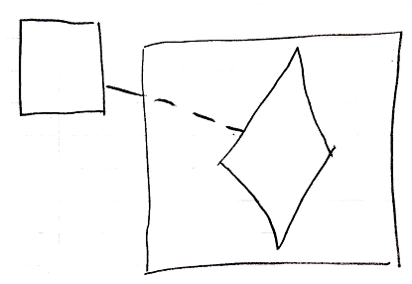

Therefore, the private contents of calls inside a definition are never created.

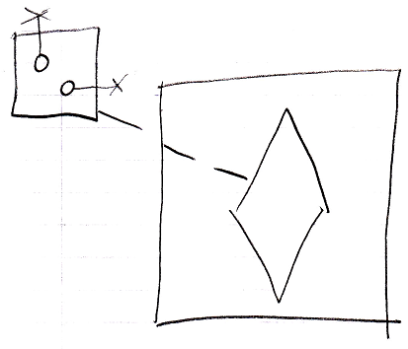

A call in a definition never shows the call’s private contents. The call at most shows its parameters, so the public contents of the command call.

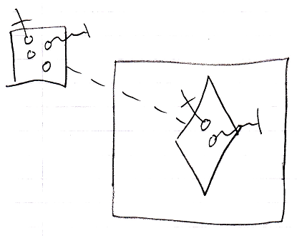

Only the definition of the called command will show private contents.

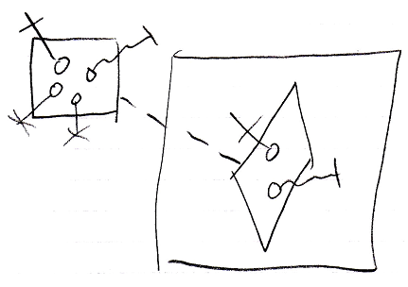

So you have to hop to the definition of a call to see the private contents of the command.

Not creating a call’s private contents before it even runs, takes away discussion about when to display and when not to display a command’s private contents.

Bear in mind, that when an executable object does not redirect its definition, it has to define its own private contents, because nothing else defines its private contents but he himself.

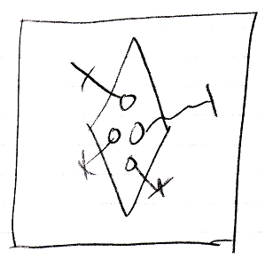

But calls inside such a definition, only have their public contents are created again.

